The Municipality of the District of St. Mary’s provides assistance to homeowners to help pay their residential property taxes. Qualified applicants will receive a credit which is applied directly to the tax account.
To Qualify:
- You must be a Canadian citizen and permanent resident of St. Mary’s Municipality, and
- Own the assessed property and occupy it as your primary residence, and
- Prior year’s property taxes must be paid in full, and
- Annual income from all sources for the previous calendar year for yourself, spouse, and other adults that reside in the same household/assessment account must total to one of the ranges below (based on line 150 of the income tax Notice of Assessment), and

Exemption Value: The exemptions provided will be based on the following total income levels:

Total Income Range | Tax Exemption Amount
$25,776-$29,899 | $210
$20,621-$25,775 | $260
$15,446-$20,620 | $310
$0-$15,465 | $365

How to Apply:
- After you have filed your personal income tax return for 2025 and received your Notice of Assessment from Canada Revenue Agency, complete the Municipal Application for Residential Low Income Property Tax Exemption form
- Attached copies of the 2025 Canada Revenue Agency (CRA) Notice of Assessment for each adult residing in the home/assessment account
- Sample Notice of Assessment from Canada Revenue Agency (CRA)
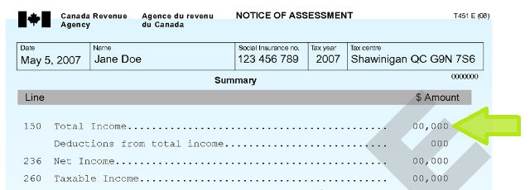
- If you do not have your CRA Notice of Assessment for 2025 you can call 1-800-959-8281
- Applications must be received by the Municipality no later than December 31, 2026
- Applicants must re-apply each year.
Tax Account #
Name of Property Owner(s)
Complete Mailing Address

Telephone #
# of Adults (age 18 or over) residing in home/ assessment account

- Applicant total income (line 150) $_________________
- Spouse/Common-Law Partner (line 150) $_________________

- Other individuals (including tenants living on the AAN or others within the household) (line 150) $_________________

TOTAL of all Income from above $_________________

*Proof of income must be provided (Copy of 2025 CRA Notice of Assessment for each adult living on the the property (AAN))

I of
in the Municipality of the District of St. Mary’s, in the County of Guysborough and Province of Nova Scotia, hereby apply for the RESIDENTIAL LOW INCOME PROPERTY EXEMPTION on taxes.

I/we, residents of the Municipality of the District of St. Mary’s, the owners and occupants (including all rental tenants on property) of the above property, certify that the information on the application is true and complete, and that the total income from all sources during 2025 was below the limit set out in this application. I/we understand the exemption for 2026/2027 is based on total income range. I/we understand that no application for an exemption will be received after December 31, 2026. I/we understand that no exemption will be granted to low-income applicants if prior year’s taxes remain unpaid.

Signature(s) Date:

To be signed by Councillor, Municipal Admin Staff or Commissioner of Oaths

Sworn to in the County of Guysborough and the Province of Nova Scotia this ____ day of _____________20___

Signature:

