Grant Announcement: Municipality of if the District of St Mary’s Receives Project Funding

St Mary’s has received $131,399.50 from the province via the Municipal Capital Growth Fund. The funding will go towards improving the capability and efficiency of our Sherbrooke water and wastewater public utility services.

Councilor Beulah Malloy attended the provincial announcement in Guysborough on June 14 for local projects awarded funding under the Municipal Capital Growth fund.

Quote from Councillor Malloy as presented at the grant announcement meeting in Guysborough:

“The province’s assistance allows St. Mary’s to make vital improvements to water and sewer utilities, providing long term benefits and helping to control costs for residents and businesses who pay to use these services. Keeping our public utilities modern and efficient is critical for service reliability and reduces long term repair costs. These investments are also essential for growth – increasing our capacity for housing, a new and redeveloped Sherbrooke long term care facility, and hopefully a great future use for the existing long term care building. Thanks to the boost from the Municipal Capital Growth Program, St. Mary’s will be ready for growth!”

Group Picture at the Grant Announcement
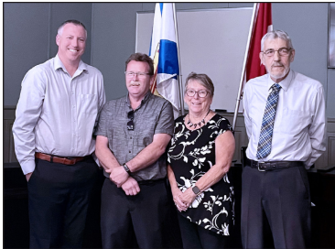

Picture Caption. From left to right: Guysborough-Tracadie MLA and Minister of Agriculture Greg Morrow (left) – with Town of Mulgrave Mayor Ron Chisholm, Municipality of the District of St. Mary’s Councillor Beulah Malloy and MODG Warden Vernon Pitts
Background: Community Benefits:

The two utilities serve over 150 customers including families and approximately 18 local businesses including food stores, an automobile service, a local gas station, a bank, and a local pharmacy. Keping both utility services modernized and efficient helps us all. Even for residents who don’t directly use the utilities there is still a critical benefit through access to all of the local services, or through having children who attend St. Mary’s Academy, or for those of us who have family residing at the High-Crest Sherbrooke long term-care home. We would all have much longer drives to communities outside of St. Mary’s if we didn’t have this local business and service hub that is supported by local utilities.

