St. Mary’s
Before and After Care Program
Parent Handbook
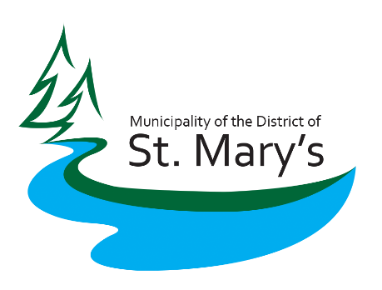

Table of Contents
Introduction……………………………………………………………………………………1
Bookings & Payments……………………………………………………………………….2
Holidays and Professional Development Days…………………………………………3
Program information………………………………………………………………………..4
Behaviour Guidance Procedure……………………………………………………………5
……………………………………………………………………………………………………6
Communications Plan……………………………………………………………………….7
……………………………………………………………………………………………………8
Appendix A - Medical Administration Permission form……....…………………….9
Appendix B - Incident Response Procedure…………………………..………………..10
Appendix C - 24 Hour Movement Guidelines…………………………………………..11
……………………………………………………………………………………………………12
……………………………………………………………………………………………………13
……………………………………………………………………………………………………14
Appendix D - Help us Get to Know Your Child…………………….…………………..15
……………………………………………………………………………………………………16
Appendix E – Bus Note Template…………………………………………….…………..17

Introduction
Welcome to the Before and After Care Program. This program is being delivered by the Municipality of the District of St. Mary’s through the Community Development & Recreation Department. Funding for this program comes from the Government of Nova Scotia through the departments of Education and Early Childhood Development and Communities, Culture and Heritage.
The Before and After Care Program is designed to support the Pre-Primary Program by giving families supports in the before and after school time periods. The program is a paid service that is available to children in grades pre-primary to grade six. Our program will take place at St. Mary’s Education Centre and Academy mainly in the Kids First room but utilizing the playground and outdoor areas and the gymnasium as well.
This document will outline how our program will be organized (booking and payments) and will include our guiding principles, policies and procedures and general information regarding the program for parents and guardians.

Bookings and Payments
The St. Mary’s Before and After Care Program is a paid service. We have a cap of 24 participants at the program. This section will outline how we will accept payments and take bookings for the program. This program is designed to make life easier for families with young children in St. Mary’s, please call us if you have any questions or concerns regarding these procedures.
Bookings
The Before and After Care Program will be offered Monday to Friday. Before Care will be available from 7:30 – 8:30 a.m. Staff will ensure that children get to their first class on time each day. After Care will be available from 2:30 to 5:30 p.m. Children do not have to attend both services, and can attend either or.
Parents MUST provide a note in their child’s agenda or in their back pack that states that they will be attending the Before and After Program. This is to inform teachers and administration that children will be attending the program instead of getting on the bus.
In order to ensure that we do not exceed our cap of 24 children in the program and to properly prepare for the program each day, we will be taking bookings over a two week period (bi-monthly). Please contact our program supervisor by email or phone to book a place for your child when you need one. An email reminder will be sent out prior to the two week period to remind you to book spaces.
Understanding that families’ lives can be busy and things come up unexpectedly, we will accept mid-week bookings with 24 hour notice. There will be no drop-ins at this program.
To book a spot:
Email: recreation@saint-marys.ca or call program supervisor: 902-328-4089
Payments
The Before and After Care Program will cost $5 for the before care service and $15 for the after care service. That is a total of $20 per day for both services. There is a discount for each additional child that attends the program, for additional children the before care service will be $3 and the after care service will be $10.
Payments can be made in several different ways depending on where a parent/guardian would like to pay. Here is an outline of payment options:
On site at program: Cash and cheque
Municipal Office: Debit, cash and cheque
Online: Online payments can be set up by calling (902)522-2049
Subsidy
The Before and After Care Program does qualify for a provincial child care subsidy. Subsidies are paid directly to the Municipality for families that qualify and sign up. Visit https://www.ednet.ns.ca/bap to learn more about the subsidy and find out how you can apply.

Holiday’s and Professional Development Days
The St. Mary’s Before and After Care Program takes place during regular school days. The program does not take place during storm days, holidays or professional development days that effect students in grades pre-primary to grade 6. The following are dates where the program will not take place.
October 14th, 2019 – Thanksgiving
October 25th, 2019 – Professional Development Day
November 8th, 2019 – Regional In-service (no classes P-12)
November 11th, 2019 – Remembrance Day
November 12th, 2019 – Administration & Evaluation Day (No Classes P-8)
November 28th, 2019 – In-service AM/Parent Teacher PM (No Classes P-8)
December 23rd 2019 – January 3rd, 2020 – Christmas Holiday
February 17th, 2020 – Heritage Day
March 13th, 2020 - Administration & Evaluation Day (No Classes P-8)
March 16th – 20th, 2020 – March Break
April 8th, 2020 - In-service AM/Parent Teacher PM (No Classes P-8)
April 10th, 2020 – Good Friday
April 13th, 2020 – Easter Monday
May 18th, 2020 – Victoria Day

The Program will begin on September 30th, 2019. The final day for the program will be June 26th, 2020.

Program Information
The Before and After Care Program is offered at 40 sites around the Province. The Departments of Education and Early Childhood Development and Communities, Culture and Heritage have created delivery standards that outline how the program should be organized and specific programming targets.
Program Fundamentals
The Before and After Care Program will be designed using the following guiding pillars:
- 24 hour movement guidelines – guidelines attached as appendix C.
- Outdoor Play
- Physical Literacy – is the motivation, confidence, physical competence, knowledge and understanding to value and take responsibility for engagement in physical activities for life.
- Inclusive and culturally responsive practices – refers to practices that reflects and celebrates our pluralist society and which allows children to development and learn while experiencing a sense of belonging and respect.
Using an outdoor play, movement and physical literacy-based framework will contribute to better health for children, the gaining of lifelong skills and quality early learning experiences.
Each day, children will have an opportunity to direct programming that will take place based on their interests. It will include spending 90 minutes engaged in active play and 60 minute playing outside during all seasons. Children will not participate in screen time during the program and sedentary activities will be kept to a minimum.
Staffing
The Before and After Care Program will have two staff on site at all times, a program Supervisor and a program leader. Staff will be trained in HIGHFIVE, Principals of Healthy Childhood Development and will attend Before and After Care training that is delivered by the province. Staff are also required to pass a RCMP Criminal Record Check and Nova Scotia Child Abuse Registry Check.
Nutrition
Children will be provided with a snack each and every day. Snacks will be given in the After Care portion of the program. Children will wash their hands before and after food preparation and eating. Snacks will include two food groups, with on being fruits or vegetables. Snacks will not be used to reinforce positive behaviors, as a reward or withheld as a consequence of inappropriate behavior.
Equipment
As we will be going outside each day during all seasons, children should come to the program prepared for the weather. This includes rain jackets and boots for rain and winter clothing in the colder months.

Behaviour Guidance Procedure
The following is the behaviour guidance procedures that our staff will use at the Before and After Care Program.

Philosophy
At the Municipality of the District of St. Mary’s we provide a nurturing and loving environment for each child in our care. We believe that children are capable, confident and curious, born with a natural desire to learn and engage with their world. We know that children learn best through play and therefore we provide an inclusive daily program with a carefully planned environment, rich with opportunities for children to explore and discover the world at their own pace.
Behaviour Guidance at St. Mary’s Programs
At the Municipality of the District of St. Mary’s our trained staff put priority on building a strong and trusting relationship with all children and families knowing that children thrive in an environment in which they feel welcomed, safe and secure. Children are encouraged to express themselves in a developmentally appropriate program which is designed to offer positive experiences and to respectfully honor the needs, interests and desires of all children.
At the Municipality of the District of St. Mary’s, we focus on ways to prevent inappropriate behaviour as we seek to understand reasons why they may occur. Our nurturing educators respond in ways that teach and gently guide children, protects them from harm, respects dignity and privacy and promotes children’s well-being.
Prevention
Preventative practices you will see at our programs:
- Playrooms set up as developmentally appropriate
- We teach social skills and use positive behavior strategies to support the development of appropriate social behaviour
- Model and teach appropriate use of materials and equipment (e.g. respectful environment)
- Reinforce positive social interactions with encouragement and modelling
- Offer choices and encourage decision making
- Set realistic expectations (e.g. sharing is not a realistic expectation for a toddler!)
- Set consistent limits (e.g. children feel more secure when they know their boundaries)
- Understanding that every behaviour is the communication of a message

Strategies
Our staff provide positive guidance throughout the day. We acknowledge that behaviours are communicating a message. We are responsible to use our observation skills to find out what the behaviour is trying to tell us. When challenging behaviours occur, the following strategies for solving conflicts will be applied:
- Approach quickly and calmly to stop hurtful or unsafe behavior
- Acknowledge each child’s feelings with a simple description (e.g. “You seem angry”)
- Gather information from each child involved (e.g. “Let’s talk about what happened”)
- Identify and state the problem (e.g. “You both want to sit in the same spot at circle”)
- Brainstorm solutions with the children (e.g. “What else can you do?”)
- Allow children to develop a solution and use it (e.g. “What idea do you choose?”)
- Follow up! See how the solution is working.
We believe that it can sometimes be appropriate to ignore an undesirable behaviour. However, through consistent engagement with children, our staff have opportunities to model and encourage appropriate behaviours, explain why a behaviour may be inappropriate and can support children with appropriate options. We encourage co-operative behaviour and only remove a child from a potentially dangerous situation and explain why, helping to settle them into another activity. There may be times when Behaviour Guidance Plans are created and implemented in our program. In these cases, plans are developed with the child’s family, professionals and staff as a team and are re-evaluated over time. The plan is intended to support the child through difficult situations. Children are NOT isolated for any reason (other than illness). Overall, children are supported in a wide variety of fun learning experiences every day!
Regulation 19(1) states that each licensee, Director, staff member and volunteer of a licensee must behave in a manner that does not harm any child who is attending the day care program, and must not do or permit any of the following:
- Use corporal punishment, including
- Striking a child directly or with any physical object, and
- Shaking, shoving, spanking and other forms of aggressive physical conduct
- Require or force a child to repeat physical movements;
- Use harsh, humiliating, belittling or degrading responses of any form, whether verbal, emotional or physical;
- Confine or isolate a child
- Deprive a child of basic needs, including food, shelter, clothing and bedding.
During mealtimes, we create a relaxing and enjoyable meal environment. We respect children’s ability to determine when they are hungry, and when they are full which will in turn promote heathy eating behaviours. Please note we abide by the following statements from the Food and Nutrition Standards; Section 11.1
- Staff and volunteers do not offer food to reinforce positive behaviours
- Staff and volunteers do not withhold food as a consequence for inappropriate behaviours
Food is not used as a reward for completing a task or finishing a meal (e.g. dessert will not be withheld if the child does not finish the main meal).

Communications Plan
We, at the Municipality of the District of St. Mary’s believe that good communication between families and the staff is essential for a successful Before and After School Program. To foster this communication and openness, we have developed this communication plan, which outlines formal and informal types of communication.
Formal
The following are formal communication methods for the Before and After Program:
- Registration process:
This process will include a paper registration form as well as a parent orientation on site with Before and After Care staff. Staff will outline the parent bulletin board and its use.
- Phone:
Staff will utilize phone numbers included on registration forms for contact if necessary. A phone call could be used during an emergency situation or to inform a parent of an incident at the program as well as other minor conversations that need to be had between staff and parent/guardians. This will be the most used form of communication.
- Email:
Program staff will utilize parent/guardian email addresses to send out important information regarding the program. Emails could inform parents of a storm cancellation and upcoming school professional development day or special events.
- Text:
There is a cell phone designated to the Before and After Care Program. If parents choose, text messages can be used to inform staff of last minute changes to scheduling or pick up.
Informal
The following are informal communication methods for the Before and After Program:
- Social Media:
Cancellations will always be posted on the Municipality of the District of St. Mary’s Facebook page. This is a secondary form of communication and parents will always be notified of a program cancellation through a formal method first.
- Bulletin Board:
Program information will be posted on the program bulletin board. This will serve as a reminder as important program information will always be given to parent/guardians through a formal communication method.
- Pickups/drop offs:
Communication will be quick and face-to-face during pickups and drop-offs at the program.

Communication from Parent/Guardians
The Before and After Program requires parents to pre-book and pre-pay for children’s use on a bi-monthly basis. A schedule of deadlines for use and payments will be provided to parents to minimize confusion. Understanding that family schedules can be hard to manage and situations always arise without notice, staff will accept children at the program with one days’ notice. The following is the requirements for parent/guardian communication to program staff.
- Children Absence:
Parent/Guardians are expected to contact the program if the child will not be attending (ex. Illness, vacation). 24 hours’ notice is required (exemptions made for emergency situations or illnesses)
- Children Pick-up:
Parent/guardian must notify program staff to identify who is permitted to pick up the child. Children will not be released to individuals who are not on the pick-up list. A list of approved individuals is required and included on the program registration form. Parent/guardians can add individuals to that list at any time by contacting program staff.
- Children Scheduling/payments:
Parent/guardians can book spots and make payments through several means.
- Program site – Program staff can accept payment for the program on site at the program. Methods of payment accepted on site are cash and cheque.
- Municipal Office – Municipal staff can accept payments for the program at the Municipal Building at 8296 Hwy. 7. Methods of payment accepted at the municipal office are cash, cheque and debit.
- Online payment – online payments can be made for this program. To set up an online payment, please contact 902-522-2598.
- Program concerns/questions:
If parents/guardians have a question or concern, they can speak directly to program staff by phone or in person. Parent/Guardians can also contact the Department of Community Development and Recreation who oversees the program.
Please note: the Before and After Care program is a program of the Municipality of the District of St. Mary’s. No communication regarding this program should be made to St. Mary’s Education Centre/Academy.
Important Contact Information
Before and After Care Program Staff
Donna-Lynn Provost | Program Supervisor | Email: Recreation @saint-marys.ca | Cell: 902-323-4089
Faith Lace | Program Leader | Recreation @saint-marys.ca | Cell: 902-323-4089
Community Development and Recreation Department
Kerri Penney | Director of Community Development and Recreation | Kerri.penney@saint-marys.ca | 902-522-2598 or 902-870-9882
Ashley MacLennan | Active Living Coordinator | Ashley.maclennan@saint-marys.ca | 902-522-2598
St. Mary’s Before and After Care Program
Medication Administration Permission Form
Please fill out this form in its entirety to give permission to the Before and After Care Program staff to administer medication to your child. Please go over this form with staff to ensure that they understand the full instructions and can ask any questions if need be. All medication that parents wish to be administered need to be labelled with child’s name in be kept in an appropriate container.
Child’s Name: __________________________________ Age: ____________________________
Physicians Name: ___________________________ Physician’s Number: ___________________
Name of Medication: ____________________________________________________________
Amount(s) to be Given: __________________________________________________________
Date(s) and Time(s) to be given: ___________________________________________________
______________________________________________________________________________
Special Instructions: _____________________________________________________________
____________________________________________________________________________________________________________________________________________________________
Medication Storage:_____________________________________________________________
______________________________________________________________________________Start Date: ____________________________ End Date: _______________________________
Possible Side Effects: ____________________________________________________________
____________________________________________________________________________________________________________________________________________________________Stop medication if the following reaction is observed:__________________________________
____________________________________________________________________________________________________________________________________________________________
Additional information/comments: _________________________________________________
__________________________________________________________________________________________________________________________________________________________________________________________________________________________________________


Municipality of the District of St. Mary’s

Before and After Care
Incident Response Procedure
Purpose:
The purpose of this policy is to outline how staff will respond to an incident that takes place at the Before and After Care Program.
Procedures:
Response:
The following is how staff should respond to a serious incident or accident:
- Staff member will immediately secure emergency medical assistance.
- Staff member will notify child’s parent or guardian.
- Staff member will notify the school principal or pre-primary manager.
- Staff member will notify a Monitoring team member

Documentation:
Program staff are to complete a Summary Report (for incident or accident) when First Aid Treatment is carried out on a child or when an injury becomes apparent (such as bruising, swelling, cuts, scratches or bites). Summary Reports are useful tools to identify recurring patterns in the program and generate possible solutions. Reports should be completed immediately following the incident by the staff who witnessed the incident and provided first aid.

When filling out a report, please remember the following:
- The child’s full name, the date, the time.
- A summary account of what happened, never assume. If an incident account is told by the child then write “Sarah told me that………”
- Parents are to read the Summary Report and encouraged to sign the form.
- The report is to be filed in the child’s folder in the office.
- A copy of the Report may be provided to the Parent/Guardian(s) when requested.

Definition:

A serious incident means any of the following:

- the death of a child while the child is attending a Before and After program
- any injury that requires emergency medical attention
- a fire or disaster at the facility
- when operational or safety issues arise.

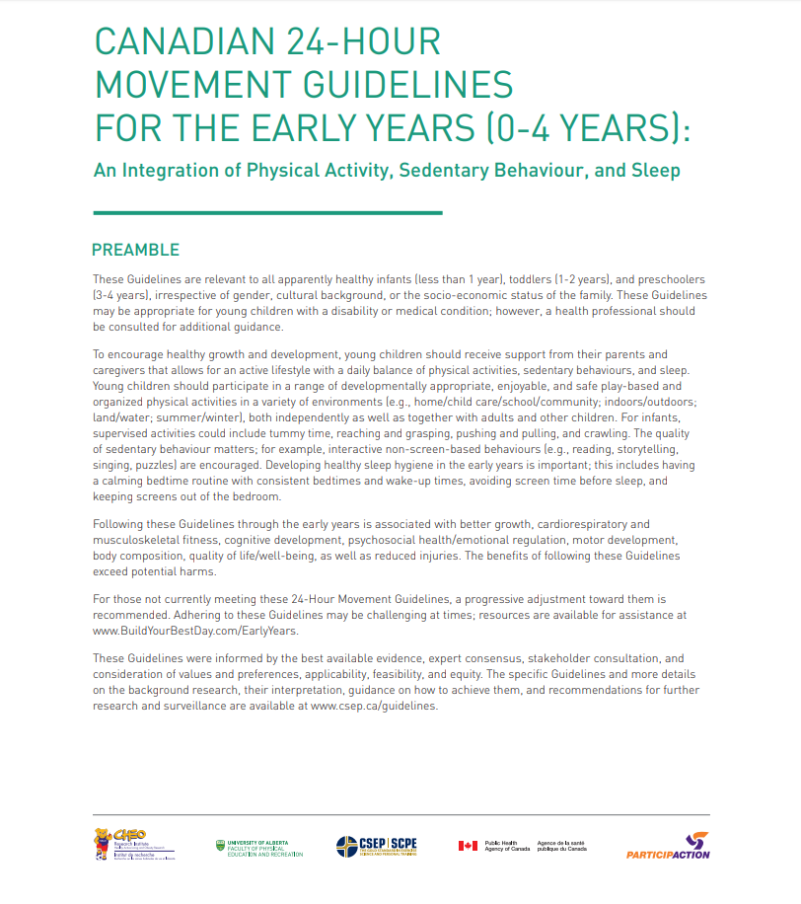

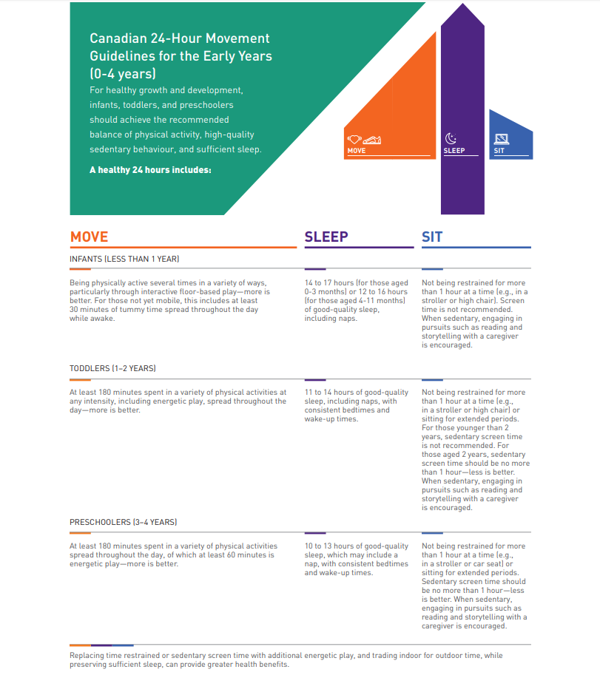

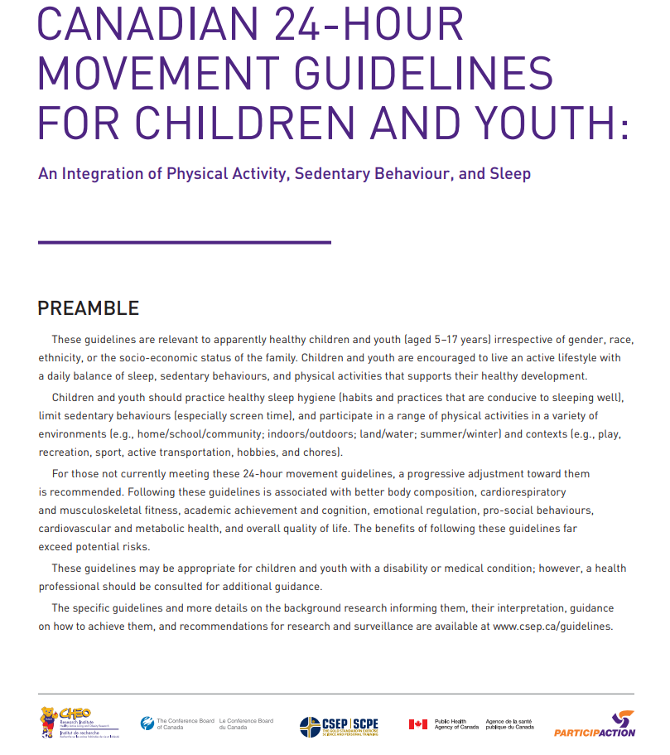

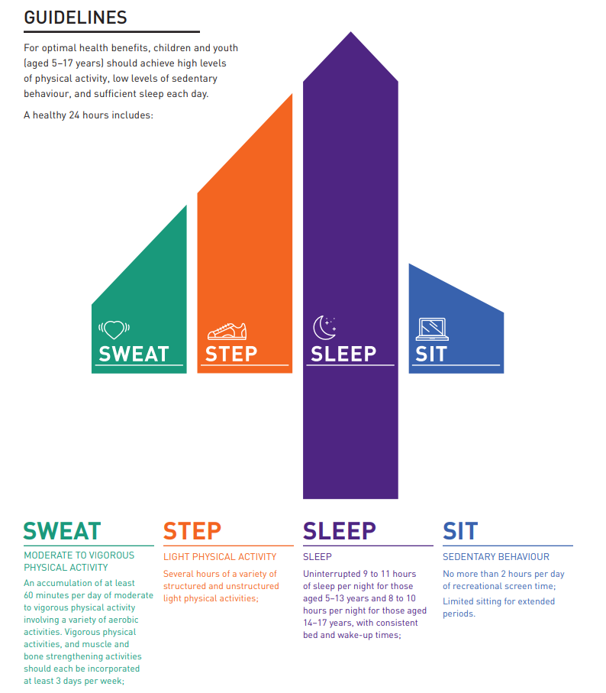

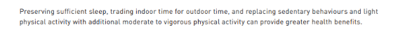

Municipality of the District of St. Mary’s

Help us Get to Know Your Child
Help us get to know your child
Please take some time to fill out this form. The information included in this form is completely confidential and will be used to ensure we give the best, most individualized experience to your child at the Before and After Care Program.
Child’s name: _______________________________________
What are you child’s strengths that assist with their ability to participate in activities?
_____________________________________________________________________________
_____________________________________________________________________________
_____________________________________________________________________________
_____________________________________________________________________________
What are the main challenges that impact your child’s ability to participate in activities?
_____________________________________________________________________________
_____________________________________________________________________________
_____________________________________________________________________________
_____________________________________________________________________________
List 5 – 10 activities that your child enjoys:
_____________________________________________________________________________
_____________________________________________________________________________
_____________________________________________________________________________
_____________________________________________________________________________
List activities that your child can do unsupervised:
_____________________________________________________________________________
_____________________________________________________________________________
_____________________________________________________________________________
_____________________________________________________________________________
Is there anything that would interfere with your child’s ability to learn new skills?
_____________________________________________________________________________
_____________________________________________________________________________
_____________________________________________________________________________
_____________________________________________________________________________
List situations where your child may becoming upset or irritated?
_____________________________________________________________________________
_____________________________________________________________________________
_____________________________________________________________________________
_____________________________________________________________________________
Describe things that make your child happy or settle them down if they become upset or irritated.
_____________________________________________________________________________
_____________________________________________________________________________
_____________________________________________________________________________
_____________________________________________________________________________
Please discuss any medications, allergies or limitations in diet:
_____________________________________________________________________________
_____________________________________________________________________________
_____________________________________________________________________________
_____________________________________________________________________________
Is there any other information that you feel is necessary to give us?
_____________________________________________________________________________
_____________________________________________________________________________
_____________________________________________________________________________

Municipality of the District of St. Mary’s

Bus Note Template
Parents MUST provide a note in their child’s agenda or in their back pack that states that they will be attending the Before and After Program. This is to inform teachers and administration that children will be attending the program instead of getting on the bus. Here is a generic template of notes that parents can use to inform school staff that their child or children will be staying at the program.

_______________________________(Child’s Name) will be staying after school at the St. Mary’s Before and After Care Program in the Kids First Room. Thank you, ___________________________________________ (Print parent’s name) __________________________________________ (signature) Date: _________________________________________
_______________________________(Child’s Name) will be staying after school at the St. Mary’s Before and After Care Program in the Kids First Room. Thank you, ___________________________________________ (Print parent’s name) __________________________________________ (signature) Date: _________________________________________

_______________________________(Child’s Name) will be staying after school at the St. Mary’s Before and After Care Program in the Kids First Room. Thank you, ___________________________________________ (Print parent’s name) __________________________________________ (signature) Date: _________________________________________
_______________________________(Child’s Name) will be staying after school at the St. Mary’s Before and After Care Program in the Kids First Room. Thank you, ___________________________________________ (Print parent’s name) __________________________________________ (signature) Date: _________________________________________
_______________________________(Child’s Name) will be staying after school at the St. Mary’s Before and After Care Program in the Kids First Room. Thank you, ___________________________________________ (Print parent’s name) __________________________________________ (signature) Date: _________________________________________
_______________________________(Child’s Name) will be staying after school at the St. Mary’s Before and After Care Program in the Kids First Room. Thank you, ___________________________________________ (Print parent’s name)
__________________________________________ (signature) Date: _________________________________________
_______________________________(Child’s Name) will be staying after school at the St. Mary’s Before and After Care Program in the Kids First Room. Thank you, ___________________________________________ (Print parent’s name) __________________________________________ (signature) Date: _________________________________________
_______________________________(Child’s Name) will be staying after school at the St. Mary’s Before and After Care Program in the Kids First Room. Thank you, ___________________________________________ (Print parent’s name) __________________________________________ (signature) Date: _________________________________________

