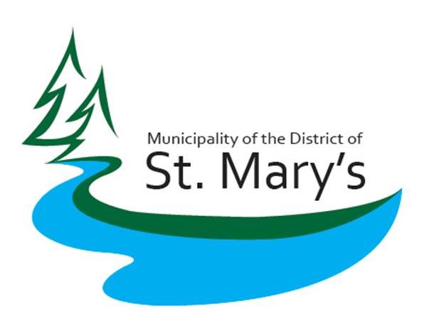
MUNICIPALITY OF THE DISTRICT OF ST.MARY’S
P.O. BOX 296, SHERBROOKE, NOVA SCOTIA, B0J 3CO

November 5, 2019

Testing for Lead and Copper in the Municipal Drinking Water in the Sherbrooke Water Utility

Recent media articles have highlighted concern regarding the levels of Lead and Copper in drinking water in Canada. Additional information from the Strait Regional Centre for Education on November 4th indicated levels of lead exceeding the new Health Canada Guidelines were detected at certain locations within the St. Mary’s Education Centre/Academy.

The Municipality of the District of St. Mary’s test for lead and copper levels as part of the quarterly sampling procedure required by the Nova Scotia Department of Environment. In all of the sampling done at St. Mary’s lead has never been detected and cooper levels have all been below the new Health Canada Guidelines, with the maximum reading over the past year being 0.008 mg/L and an average of 0.0055 mg/L.

There are no lead or copper lines or fittings in the entire water distribution system for the Sherbrooke water utility. This includes everything up to and including the curb stops (shut off). The municipality is not responsible for any lines or fittings beyond the curb stops.

Please contact Ricky Kaiser, Superintendent of Public Works at 902-522-2156 or 902-328-4154 with any questions on the water supply system and testing procedures.

